Use Case Specification

DMT/RM01/TMP

|  |  |
| --- | --- |
| Project Code | PRJ_hotel_booking_management_01 |
| Project Name | Hotel Booking Management |

|  |  |  |
| --- | --- | --- |
| Prepared/Modified by | Role | Date of Preparation |
| Stella Rosy S R  Sivanesh C  Saraswathi V  Susmitha S  Noor Mohammed P  Hemalatha P | Analyst | 24/05/2018 |
| Reviewed by | Role | Date of Review |
|  |  |  |
| Approved by | Role | Date of Approval |
|  |  |  |
| Circulation List |  | Version Number of the template:1.0 |
| Version Number | 1.0 |  |

<<Customer>> REVIEW HISTORY

<<Customer comments on the Use case along with the signed off is tracked here>>

|  |  |  |  |  |  |  |
| --- | --- | --- | --- | --- | --- | --- |
| Version | <<Version number>> |  |  |  |  |  |
| Date | <<Date of Review>> |  |  |  |  |  |
| Reviewed by | << Reviewer Name>> |  |  |  |  |  |
| Reviewed UI Specification doc | << Whether UI Specification doc is reviewed >> |  |  |  |  |  |
| All Open Queries/issues closed | << Whether all the open queries and issues resolved>> |  |  |  |  |  |
| Agreement on Assumptions | <<Whether all the assumptions have been agreed upon by the customer>> |  |  |  |  |  |
| Sign Off | <<Signature>> |  |  |  |  |  |

Disclaimer:

The scope of the project ‘<<Project Name>>’ is restricted to the contents of this signed off use case.

TABLE OF CONTENTS

1.Use Case Name: <<Use Case Name>> ………………………………………………………………………..4

2.Actor(s) ……………………………………………………………………………………………………………...4

3.Preconditions……………………………………………………………………………………………………….4

4.Flow of Events. …………………………………………………………………………………………………….4

4.1 Basic Flow……… …………………………………………………………………………………………………….4

4.2 Alternative Flows……… …………………………………………………………………………………………...5

4.2.1 Alternate Flow 1………. …………………………………………………………………………………………...5

4.3 Sub Flows……. …………………………………………………………………………………………………….6

4.3.1 Sub Flow 1…… …………………………………………………………………………………………………….6

5.Post Conditions …………………………………………………………………………………………………….6

6.Special Requirements... …………………………………………………………………………………………...7

7.Extension Points……… …………………………………………………………………………………………...7

<Name of extension point>…. …………………………………………………………………………………………...7

8.Business Rules …………………………………………………………………………………………………….7

9.Diagrams…….. …………………………………………………………………………………………………….8

Use Case Diagram…. …………………………………………………………………………………………………….8

10.Scenarios…….. …………………………………………………………………………………………………...10

Success Scenarios…. …………………………………………………………………………………………………...10

Failure Scenarios…… …………………………………………………………………………………………………...10

11.Issues …………………………………………………………………………………………………………….10

12.UI Specifications……… ………………………………………………………………………………………….10

13.Inter System Dependencies…... ………………………………………………………………………………...11

14.Integration with an already existing System of the <<Customer>>……… …………………………………11

15.Assumptions…. …………………………………………………………………………………………………...11

REVISION HISTORY OF THE WORK PRODUCT…………………………….. .. …………………………………...12

1. Use Case Name: booking hotel room in HBMS

**Use Case ID:**  user.booking_001

**Brief Description:** This use case describes the process by which user can login to webpage and book hotel room.

1. Actor(s)

User – Customer / Hotel Employee

1. Preconditions

User has already registered with Hotel Booking Management System.

User has valid username and password.

User is aware of all the steps to book an hotel room.

1. Flow of Events

4.1 Basic Flow

**Name:** Successful hotel room booking.

User enters the url on the browser.

Click on login link and system navigates user to login page.

User enters valid credentials.

System validates credentials and navigates user to main option screen.

User clicks on search hotel and system navigates user to search hotel page.

User enters search city.

User enters arrival date.

User enters departure date.

User clicks on search button.

System validates entered details and navigates user to page displaying list of hotel.

User selects the hotel and clicks on book button corresponding to it.

System navigates User to book Now page with information of available rooms, rate etc.

User enters No of rooms to be booked.

User enters No of adults.

User enters No of children.

User clicks on Book button.

System validates entered details and dsiplays regarding successfully booking.

* 1. Alternative Flows

4.2.1 Alternate Flow 1: Booking room from favourite hotels list.

User enters the url on the browser.

Click on login link and system navigates user to login page.

User enters valid credentials.

System validates credentials and navigates user to main option screen.

User clicks on account history.

User clicks on favourite hotels option.

System displays list of hotels previously added to favourites list by that particular user.

User selects the hotel and clicks on book button corresponding to it.

System navigates User to book Now page with information of available rooms, rate etc.

User enters No of rooms to be booked.

User enters No of adults.

User enters No of children.

User clicks on Book button.

System validates entered details and dsiplays regarding successfully booking.

4.2.1 Alternate Flow 2:User has already logged in and proceeds to book room.

User clicks on search hotel and system navigates user to search hotel page.

User enters search city.

User enters arrival date.

User enters departure date.

User clicks on search button.

System validates entered details and navigates user to page displaying list of hotel.

User selects the hotel and clicks on book button corresponding to it.

System navigates User to book Now page with information of available rooms, rate etc.

User enters No of rooms to be booked.

User enters No of adults.

User enters No of children.

User clicks on Book button.

System validates entered details and dsiplays regarding successfully booking.

4.2.2 Alternate Flow 3

Exception Flow 1: Entering Into Application With Invalid Credentials.

User enters the url on the browser.

Click on login link and system navigates user to login page.

User enters invalid username.

User enters password

User clicks on login button.

System validates credentials and displays error message.

Exception Flow 2: Booking more no of rooms than available.

1. User clicks on search hotel and system navigates user to search hotel page.

2. User enters search city.

3. User enters arrival date.

4. User enters departure date.

5. User clicks on search button.

6. System validates entered details and navigates user to page displaying list of hotel.

7. User selects the hotel and clicks on book button corresponding to it.

8. System navigates User to book Now page with information of available rooms, rate etc.

9. User enters No of rooms to be booked.

10. User enters No of adults.

11. User enters No of children.

12. User clicks on Book button.

13. System displays error message regarding no of more to book exceeds limit.

Exception Flow 3: Network Connectivity Error

1. User enters the url on the browser.

2. System displays error message regarding network connectivity

Exception Flow 4: Database Connectivity Error

1. User enters the url on the browser.

Click on login link and system navigates user to login page.

User enters invalid username.

User enters password

User clicks on login button

System tries to validate username and password.

System displays an error message regarding database connectivity problem.

POST CONDITION

| Flow Name | Post Condition |
| --- | --- |
| Successful hotel room booking. | System displays message regarding successful hotel room booking. |
| Booking room from favourite hotels list. | System displays message regarding successful hotel room booking. |
| User has already logged in and proceeds to book room. | System displays message regarding successful hotel room booking. |
| Entering Into Application With Invalid Credentials | System validates credentials and displays error message. |
| Booking more no of rooms than available. | System displays error message regarding no of rooms to be booked limit exceeds. |
| Network Connectivity Error | System displays an error message regarding network connectivity. |
| Data Connectivity Error | System displays error message regarding database connectivity |

1. Special Requirements
2. Performance
3. When user clicks on book option system should display book now page within 15 seconds of user request.

Availability

**1.** User can book hotel room 24x7.

2. Application is up and running 24*7.

User Interface

1.The letters on Menus shall be bold

2.The active links shoul be displayed in red color

3.The visisted links should be displayed in purpule color

4.The Unvisited links should be displayed in blue

5.The logout and back button should be available on every page of the application

6.Look and feel and color of application should be proper.

7.In case of Field level validation error messages should be displayed in red color.

Security

1. User with valid credentials can only login.

2. If user enters the URL of the main option screen the system redirects the user to login page.

3. If HBMS remains inactive for 15 mins it asks to login again.

1. 7.Extension Points
2. Entering Into Application With Invalid Credentials.

In step 3 of basic flow if user enters wrong user credentials :

1. The system prompts the user to re-enter the credentials

2. User enters valid credential

3. The system takes admin to the Step 4 of Basic Flow

1. Booking room without entering number of rooms to be booked.

In step 13 of basic flow if user enters no of rooms to be booked more than available rooms :

1. The system prompts the user to re-enter the no of rooms to be booked

2. User enters no of rooms to be booked

3. The system takes admin to the step 14 of Basic Flow

2. Business Rules

| Business Rule Name | Business Rule Description | System action (if BR fails) |
| --- | --- | --- |
| BR01 | All field are mandatory in book now page | System will display error message |
| BR02 | Departure date should be same or future date of arrival date. | System will display error message regarding invalid departure date |
| BR03 | User should login before booking room | System will navigate booking to login page |

1. Diagrams

Use Case Diagram

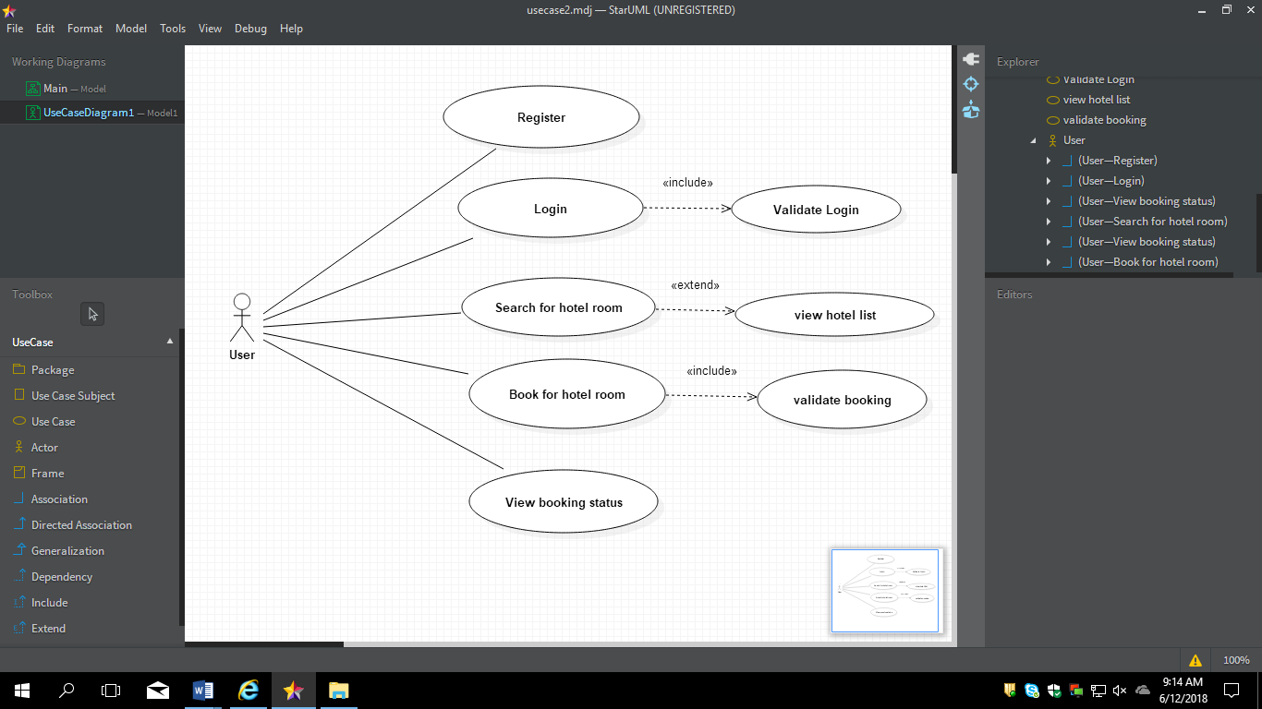

1. Scenarios

Success Scenarios

* Successful hotel room booking.
* Booking room from favourite hotels list.
* User has already logged in and proceeds to book room.

Failure Scenarios

* Entering Into Application With Invalid Credentials
* Booking more no of rooms than available.
* Network Connectivity Error
* Database Connectivity Error

1. Issues
2. What is the maximum size of username and password that user can have ?
3. What if the user is blocked after invalid login attempts for three times ?
4. UI Specifications
5. Inter System Dependencies

**Module: ‘**Book room’ gets impacted due to :

Use case name: Booking hotel room in HBMS

**Impact**: Booked status cannot be viewed hotel room is not booked

1. Assumptions
2. User has already registered with HBMS.
3. User should know the valid URL of HBMS
4. User should have Google chrome browser for best view of site.

REVISION HISTORY OF THE WORK PRODUCT

<to be maintained by projects>

|  |  |  |  |  |  |
| --- | --- | --- | --- | --- | --- |
| # | Date | Version # | Section Changed | Details of changes made | Approved By |
| 1 |  |  |  |  |  |
| 2 |  |  |  |  |  |